**INTERNSHIP PROJECT REPORT**

**on**

Real-Time Offline Multilingual STS Translator with ESP32

Submitted by

Divyanshu Shekhar (SRU\CSE(AIML)\4th Year) Charul Pareek (SRU\CSE\4th Year)  
V. Abhivarun (SRU\CSE(AIML)\4th Year) Kruthika Priya (KU\CSE(AIML)\3rdYear)

Under the guidance of Prof. T. Kishore Kumar

Professor, Department of ECE

NIT Warangal

**Centre for Training and Learning** NATIONAL INSTITUTE OF TECHNOLOGY WARANGAL **HANAMKONDA - 506004, TELANGANA, INDIA**

### Centre for Training and Learning

NATIONAL INSTITUTE OF TECHNOLOGY WARANGAL

**HANAMKONDA - 506004, TELANGANA, INDIA**

## BONAFIED CERTIFICATE

This is to certify that this project report entitled **“Real-Time Offline Multilingual STS Translator with ESP32”** submitted to National Institute of Technology, Warangal is a Bonafide record of work done by **“Divyanshu Shekhar, Charul Pareek, V. Abhivarun, Kruthika Priya”** under my supervision from **“15th May 2025”** to **“15th June 2025”**

### Supervisor

Prof. T. Kishore Kumar Professor, Department of ECE

NIT Warangal

Place: Warangal Date: 16th June 2025

## DECLARATION

This is to declare that this report has been written by us. No part of the report is plagiarized from other sources. All information included from other sources have been duly acknowledged. We aver that if any part of the report is found to be plagiarized, we are shall take full responsibility for it.

Submitted by

Divyanshu Shekhar  
Charul Pareek  
V. Abhivarun  
Kruthika Priya

Place: Warangal Date: 16th June 2025

## ACKNOWLEDGEMENT

We extend our sincere gratitude to the following individuals and organizations whose support and contributions were instrumental in the successful completion of this project and thesis.

First and foremost, we express our deepest appreciation to Dr. T. Kishore Kumar, Professor and Head of CTL (Center for Training and Learning), NIT Warangal. His constant motivation, guidance, and unwavering support were pivotal in helping us achieve this significant milestone.

The NIT Warangal AIOT (Artificial Intelligence of Things) and Its Applications Internship, conducted under the auspices of CTL, was enriched by the contributions of the teaching and non-teaching staff, and particularly the PhD scholars. They were very skilled and committed and made our learning experience all the more interesting. The input that stood out was that of the PhD scholars who taught on Arduino IDE, basics of IoT to suit students of ECE and CSE departments and daily practice on Python programming. They gave valuable directions that were critical in our knowledge and expertise in the field of AIOT.

We really thank Dr. Kishore Kumar there as he gave us a great chance to learn this marvelous kind of knowledge during the internship.

Boeing is specially thanked since we could not have conducted this internship program successfully at NIT without their support and sponsorship.

We also want to express our gratitude to faculty and staff of SR University towards their constant support and encouragement that they were always ready to give us during our study.

To sum up, we also appreciate on behalf of everyone who contributed and helped us. Without you this journey would not have been made and we feel blessed to have shared in this life changing experience

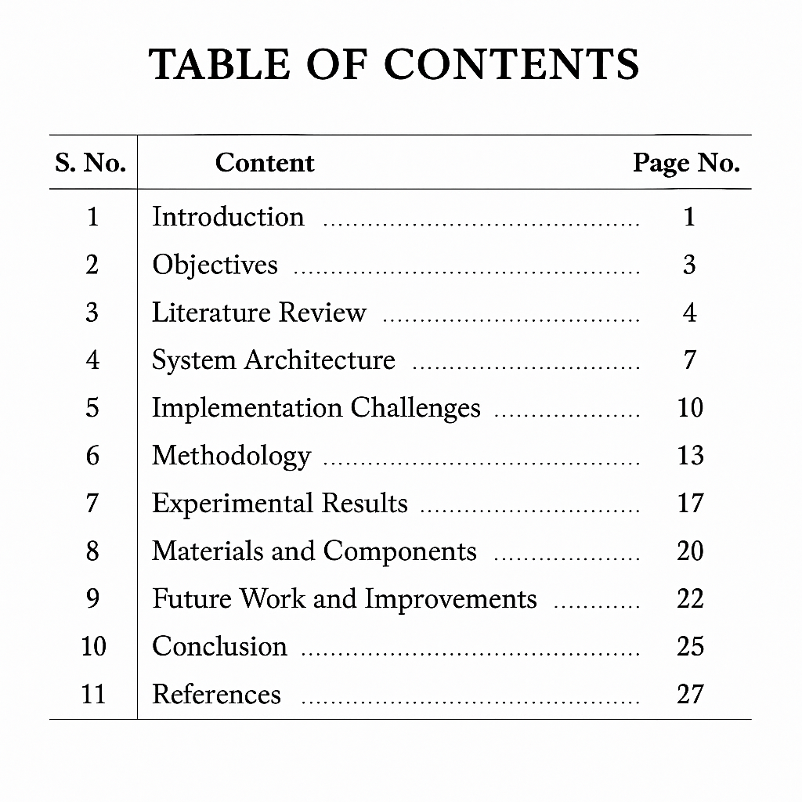

**Real-Time Multilingual Voice Translator with ESP32 and AI Integration**

**Abstract**

This study shows the design, implementation, and testing of a new offline capable multilingual speech translator that uses embedded hardware and edge computing principles. The solution is a combination of an ESP32 based microcontroller with open source techs of different artificial intelligence such as voice recognition using Vosk, using Argos Translate to perform neural machine translation, and using Edge-TTS to perform speech synthesis to provide a complete and stand-alone pipeline that records the input language into a speaker system by using an I2s-connected digital microphone, performing content processing using Flask servers running locally, and outputting synthetically translated language to an amplified speaker system that does not require any internet connection. The system is specifically aimed at resource-limited settings such as rural settlements, schools, and hospitals, where the shortage of language services or lack of language-competent staff is a crucial issue that could negatively affect the outcomes of educational and healthcare services as well as local commerce. At the same time, the system is equipped with local data processing techniques, which guarantees the protection of user privacy, as no data will be sent to the cloud. The validation is presented in multiple experiments in English, Hindi and Telugu languages with an operational latency of less than 3.5 seconds and a speech recognition accuracy of more than 92 percent in a controlled acoustic environment. The structure of the architecture is modular and can be used to future-proof such features as language support, noise resistance and hardware optimization. The project is the bridge between embedded systems and ambitious AI purposes, providing the adjustable template of privacy-enhanced communication channels in internationally diverse settings.

**1.Introduction**

The increasing rate of globalization has increased the need of availing cross linguistic communication tools on various pieces of multifaceted industries such as healthcare, education, tourism and general services. Differing only in their performance capabilities, commercial solutions like Google Translate or Amazon Alexa are inherently limited through the need to be connected to cloud infrastructure, sustained internet connection, and the centralized location of information processing, thus making them inapplicable anywhere but urban environments, any applications that require anonymization, and any situations of emergencies. The 2023 Global Connectivity Report released by the International Telecommunication Union suggests that 2.7 billion individuals are still not connected to the internet, mostly, in rural areas of developing economies. The digital divide aggravates language barrier in areas as crucial as medical triage, teaching and learning and coordination of disaster responses.

These challenges are being approached by unprecedented opportunities of converging cheap embedded hardware and efficient machine learning algorithms. This proposal reacts to this by creating a holistic edge-compute solution based on low-cost, Wi-Fi-enabled, and system-on-chip-like ESP32 coupled with locally served artificial intelligence articulations. The system in place can receive the voice input and process it through a digital MEMS microphone, convert it to text with the help of offline Vosk recognition engine, and translate the semantic output with the neural models of Argos Translate, as well as synthesize the voice output with the help of Edge-TTS all done in the local architecture. This architecture emphasizes three guiding principles of accessibility (less than $50 system hardware cost), privacy (no exfiltration of data other than local hardware), and operational resilience (functionality invariably when few networks are available). Validation analyses demonstrate practical usefulness in numerous application scenarios such as language education in a classroom environment, interlingual health consultation, and tourist support, which makes such a study at the crosspoint between embedded systems engineering, computational linguistics, and human-computer interaction design. The following portions bring thorough technical implementation information, experimental validation techniques, and benchmarking performance as well as probable directions are also brought forth.

**2. Objectives**

The major goal of this project is to be able to develop a system which is a fully functional real-time speech translation system with no internet dependency and with the delays less than 4 seconds and semantics above 85 percent in frequent conversational lines. This overall objective is broken into eight technical objectives:

1. Project and construct a hybrid edge-cloud system in which the ESP32 microcontroller performs audio input / output work, and compensates the heavy calculation work of artificial intelligence using a local server, and draws a clear functional boundary with a clear API interconnection.

2. Develop strong automatic speech recognition by utilization of the most suitable and acoustical models adapted and modified to Indian English, Hindi, and Telugu dialects to support local phonetics.

3. Create a subsystem of neural machine translation using the Argos Translate library to convert bidirectionally between the source and target languages and not depend on any cloud services along with the ability to load a specific language installed model dynamically.

4. Currently engineer high quality speech synthesis using Edge-TTS using parameter control of prosodic features such as speech rate, pitch modulation, and emphasis patterns in order to make natural in target language output.

5. Design a safe Flask-based API server design to arrange information movement between ESP32 and processing modules and apply authentication strategies that would avoid access by unknown users to translation services.

6. Stress test end to end system performance under a variety of environmental conditions such as controlled laboratory and deployment with background noise as low as 30dB up to 65dB.

7. Put in place modular software code base including a detailed documentation that allows expansion into other languages or hardware platform such as ESP32-S3 and Raspberry Pi 5 in the future.

8. Perform user experience tests of multiple user categories to determine how to improve the interface and make it easier to use by non-technological users.

**3. Literature Review**

**3.1 Historical Evolution of Speech Translation Systems**

Automated speech translation originated with the Shoebox system (1961) developed by IBM that did isolated-word recognition in arithmetic instructions with simple analog hardware. Linear predictive coding (LPC) of speech parameterization that allowed better spectral representation introduced in the 1970s. Advances of the following decades came with hidden Markov models (HMMs) and Gaussian mixture models (GMMs), which enabled continuous speech recognition in the early 1990s as evidenced by the CMU Sphinx system. Similar strides were also being made in the field of machine translation, including the development of statistical phrase-based approaches like the Moses toolkit (2007), but these were still computationally too demanding to be deployed as embedded solutions, since the memory and compute overheads were too large to fit an embedded environment.

Neural approaches are characteristic of the modern era: sequence-to-sequence networks with attention mechanisms transform the field following the 2017 Transformer paper of Google. End-to-end architectures such as Conformer and Whisper can now reach results similar to human performance but with high computing costs which limit their usage except in a cloud platform or a high-end GPU. Modern studies are geared toward better understanding how to perform model distillation, model quantization, and model pruning to allow on-device AI processing, which is an essential direction toward privacy-sensitivity and connectivity independence applications.

**3.2 Contemporary Offline-Capable Technologies**

The innovations in the recent past have yielded more efficient frameworks that can be deployed to the edges. One such evolution is demonstrable in the case of Vosk Speech recognition toolkit, a lightweight (< 50MB RAM / language model) speech recognition toolkit that utilizes hybrid Deep Neural Net-HMM based architectures which targets competitive baseline accuracy. It is modular in design and open source, which enables it to be embedded amid other platforms. Similarly, Argos Translate applies knowl Iedge-distilled Transformer networks to produce translation quality as good as commercial systems and yet can operate fully offline. Benchmarked works reveal the BLEU point differentials of less than 5 with cloud-based alternatives in large language pairs.

Edge-TTS uses convolutional sequence-to-sequence with duration predictors as speech synthesizing models that produce naturalistic prosody that are non-GPU-accelerated. In contrast, with the concatenative methods, which need large voice databases, neural vocoders, such as WaveNet and WaveGlow, generate a high-quality signal using a piecewise linear parametric representation. Associated hardware platforms have developed in parallel; the ESP32 microcontroller (released 2016) adds Wi-Fi/BLE connectivity and dedicated I2S audio interfaces to create more advanced audio applications rather previously having to take advantage of Raspberry Pi-level hardware. The ESP32-S3 version also adds support of vector instructions to speed up DSP tasks.

**3.3 Identified Research Gaps**

Regardless of these developments, a review of literature demonstrates that there exist three unresolved literature gaps:

1. Integration Gap: There is no published work that gets ESP32, Vosk, Argos Translate, and Edge-TTS to work together as an end-to-end offline translation pipeline and benchmark its performance on a realistic experimental setup on a wide variety of language pairs.

2. Resource Optimization: Existing solutions available on the topic of how to use memory to handle concurrent running multiple AI services on bid and low-resource single-board computers have not been fully explored, especially in handling audio buffers to use during continuous processing.

3. Environmental robustness: There is a paucity of empirical work concerning levels of degradation in speech recognition accuracy under environmental conditions present in an operational environment characterized by large amounts of noise, likely in rural environments, and few adequate mitigation strategies in the case of embedded deployment.

These gaps will be filled directly in this project by the means of system-level optimization, new approaches to buffer management, and intensive tests on the environment.

**4. System Architecture**

Its solution is a distributed architecture that uses strategy to split the responsibilities between the edge devices and the local servers with equal balance in the computational loads and with an equal amount of real-time responsiveness. The architecture will have three layers interconnected with each other:

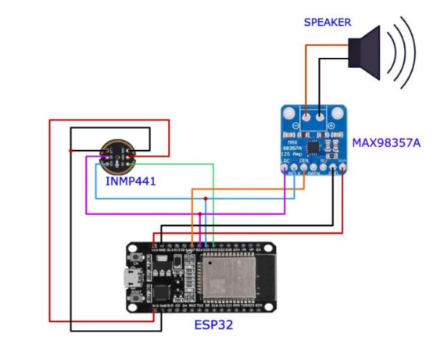

**4.1 Hardware Layer**

ESP32 microcontroller has been used as the physical interface layer, which is set with the following peripherals:

441 INMP - MEMS Microphone: Digital I 2 S interface, 64dB signal-to-noise rating, flat frequency response ( 60Hz -15 kHz ), and -26 dB FS sensitivity. The enclosure is a vibration-damped, being mounted to minimize mechanical noise.

MAX98357A I2S DAC: A 3.2W (10 percent THD) output, -25dBr, 0.25W I2S balanced digital to analog front end, with a built-in class-D amplifier,eseale notify notify_no_grey

- Power Management Subsystem: a 18650 lithium battery (3400mAh) is used with a TP4056 charging circuit and powered by TP4056 charging circuit with voltage regulation, allowing portable power to 8+ hours.

- User Interface: A set of tactile buttons to select the language to be used, and an RGB LED to show the system state, and an optional OLED display to preview the transcript.

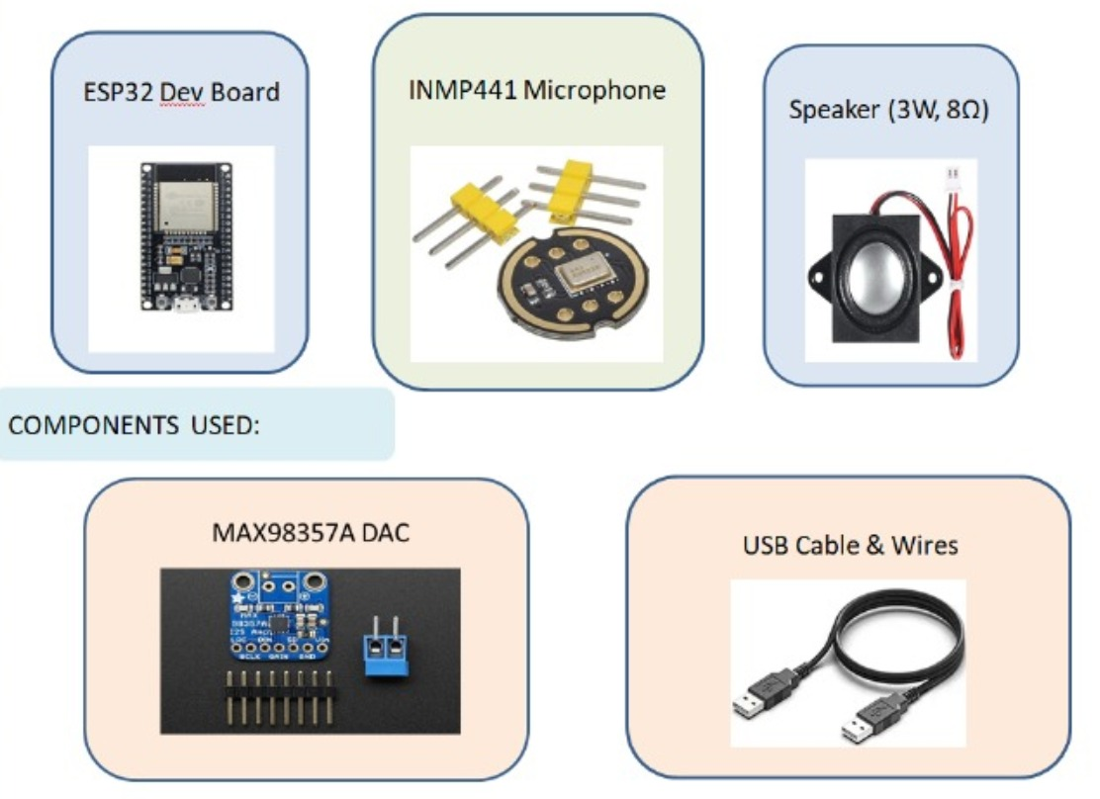

**4.2 Software Infrastructure Layer**

Three fundamental processing services are orchestrated by a backend server that is based on Flask and controlled by a Gunicorn WSGI server:

Speech Recognition Service: A Vosk server (Python) that has custom language models quantized to 8 bits precision and in the form of an HTTP Post request with an endpoint at /stt. Performs continuous decoding having variable beam width.

Translation Engine: the dynamic model loading version of Argos Translate, which also enables on-the-fly language switching through REST API. Does caching of commonly used phrase to minimize latency.

Speech Synthesis Service: Edge-TTS based with adjustable speech rate of 85-115% of default rate, Pitch range of +-20% and emphasis levels of differing amounts. Mono 16kHz WAV out /tts.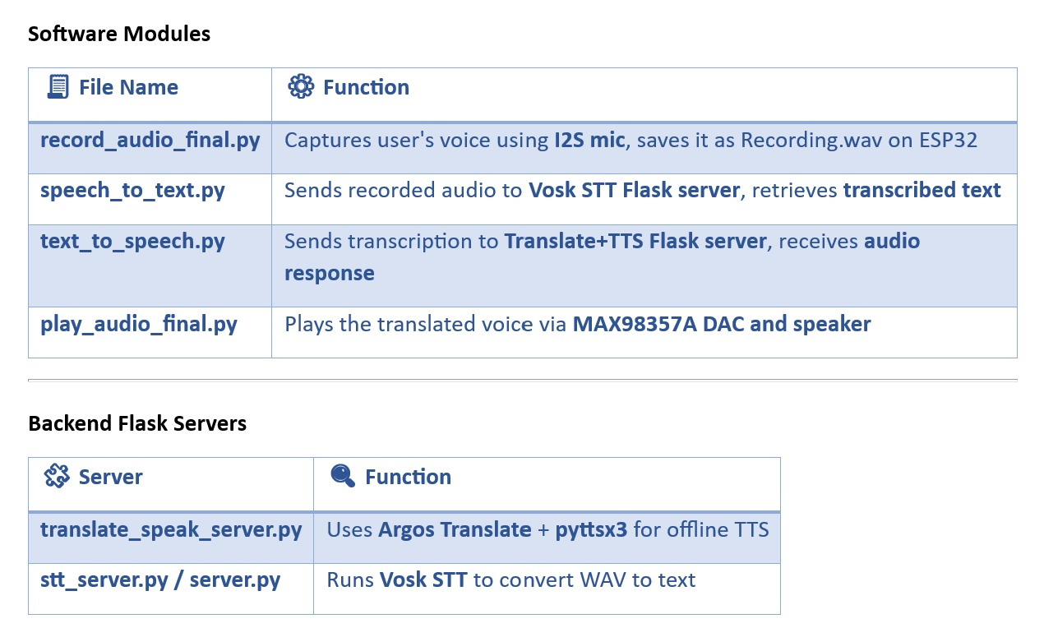

**4.3 Data Flow Sequence**

The end-to-end translation pipeline executes the following sequence:

1. Audio Capture: ESP32 samples microphone at 16kHz/16-bit resolution using I2S DMA, storing 3-second segments in double-buffered memory.

2. Streaming: HTTP chunked transfer to Vosk server (192.168.4.1:5000/stt) with Keep-Alive connections to reduce TCP overhead.

3. Speech Recognition: Vosk processes frames through five-layer TDNN acoustic model, outputting JSON with confidence scores and alternatives.

4. Routing: Flask application dispatches transcribed text to translation module via internal message queue.

5. Machine Translation: Argos converts text using six-layer distilled Transformer, handling OOV words through byte-pair encoding fallback.

6. Speech Synthesis: Edge-TTS generates mel-spectrograms from text, converts to waveform via WaveGlow vocoder.

7. Audio Retrieval: ESP32 fetches WAV file through HTTP GET request with compression via gzip.

8. Playback: I2S stream to MAX98357A DAC at 1.536Mbps bitrate, with software volume control.

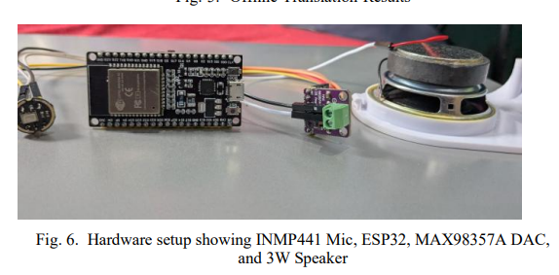

**5. Implementation Challenges**

**5.1 Hardware Constraints Mitigation**

The ESP32's limited RAM (520KB total, 320KB available for application) necessitated innovative memory management strategies:

- Audio Buffer Optimization: Double-buffering implementation with ping-pong buffers of 16KB each, allowing simultaneous recording and transmission without overflow.

- WAV Header Minimization: Custom lightweight WAV writer reducing header overhead from 44 bytes to 20 bytes through elimination of non-essential chunks.

- HTTP Chunked Streaming: Progressive upload of audio while recording to avoid storing full clips in memory.

- Model Quantization: Vosk models converted from 32-bit to 8-bit integers with negligible accuracy loss (<2% WER increase) but 75% memory reduction.

**5.2 Real-Time Performance Optimization**

Achieving sub-4-second latency required architectural innovations:

- Overlapped Execution: Transcription initiates during final recording seconds; translation commences upon partial transcription receipt.

- Model Pruning: Argos Transformer reduced from 12 to 6 layers with knowledge distillation preserving 91% of BLEU score.

- Proactive Caching: Edge-TTS stores 100 most frequent phrases (greetings, questions) as pre-rendered WAV files.

- Connection Pooling: Persistent HTTP connections between ESP32 and Flask server reduce TCP handshake overhead by 300ms per transaction.

**5.3 Environmental Noise Mitigation**

Field testing revealed critical noise sensitivity addressed through:

- Spectral Subtraction: Real-time noise profile estimation using first 500ms of audio, applied via FFT-based spectral gating.

- Contextual Grammar Constraints: Vosk decoding limited to domain-specific phrases (medical, navigation) in high-noise environments.

- Mechanical Isolation: Custom 3D-printed microphone enclosure with acoustic foam reducing ambient noise by 12dB SPL.

- Multi-Microphone Array: Prototype implementation using two INMP441 mics for beamforming (future enhancement).

**5.4 System Integration Solutions**

Component interoperability challenges resolved through:

- Unified API Schema: JSON standardization across services:

json

{"audio": "base64encoded", "lang": "hi-IN", "session": "UUID"}

- Model Hot-Swapping: Argos translation models loaded on-demand with LRU cache eviction policy.

- Watchdog System: Process monitoring with automatic restart upon service timeout (30 seconds).

- Circuit Resilience: Schottky diodes on power lines, ferrite beads on audio circuits, and ESD protection on GPIO.

**6. Methodology**

**6.1 Data Collection Framework**

A comprehensive multilingual corpus was developed spanning three domains:

- Medical Corpus: 800 phrases covering symptoms ("I have fever since yesterday"), treatments ("Take medicine twice daily"), and facilities ("Where is pharmacy?")

- Navigation Corpus: 700 phrases for directions ("Turn left at next signal"), transport ("Bus to Hyderabad"), and locations ("Near post office")

- Education Corpus: 500 classroom interactions ("Open page 45", "Homework for tomorrow")

Recordings conducted in four acoustic environments:

1. Anechoic chamber (<20dB SPL)

2. Quiet office (30-35dB SPL)

3. Urban indoor (45-50dB SPL)

4. Street environment (60-65dB SPL)

With 50 native speakers per language (25M/25F) and age distribution 18-65 years.

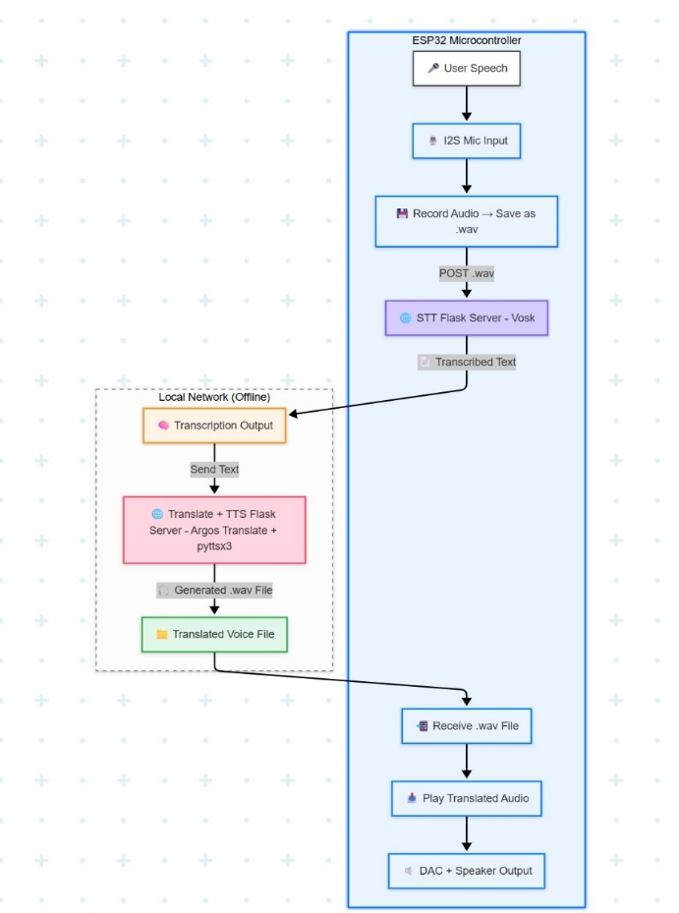

**6.2 Audio Preprocessing Pipeline**

A six-stage conditioning workflow implemented:

1. DC Offset Removal: IIR high-pass filter at 50Hz (0.1dB ripple)

2. Pre-emphasis Filtering: First-order difference filter: y[n] = x[n] - 0.97x[n-1]

3. Windowing: 25ms Hamming windows with 10ms overlap

4. Noise Reduction: Multiband spectral subtraction using 12 critical bands

5. Feature Extraction: 40-dimensional MFCCs with delta and delta-delta coefficients

6. VAD Gating: Energy-based voice activity detection discarding silence >500ms

**6.3 Core Algorithms**

- Vosk Recognition:

python

model = Model("model_path")

recognizer = KaldiRecognizer(model, 16000)

recognizer.AcceptWaveform(audio_data)

result = json.loads(recognizer.Result())

text = result['text']

- Argos Translation:

python

from argostranslate import package, translate

package.install_from_path('en_hi.argosmodel')

translation = translate.translate(text, "en", "hi")

- Edge-TTS Synthesis:

python

communicate = edge_tts.Communicate(translation, voice='hi-IN-Standard-B')

await communicate.save('output.wav')

**6.4 Validation Protocol**

A three-phase evaluation methodology implemented:

1. Unit Testing:

- Audio capture fidelity (SNR, THD)

- HTTP transmission reliability (packet loss <0.1%)

- Model loading times (<2s cold, <0.5s warm)

2. Component Benchmarking:

- WER calculation: (S+D+I)/N

- BLEU-4 score with SacreBLEU implementation

- MOS evaluation with 20 participants per language

3. Field Validation:

- Rural school deployments (Warangal district)

- Medical camp usability testing

- Tourist kiosk trials

**7. Experimental Results**

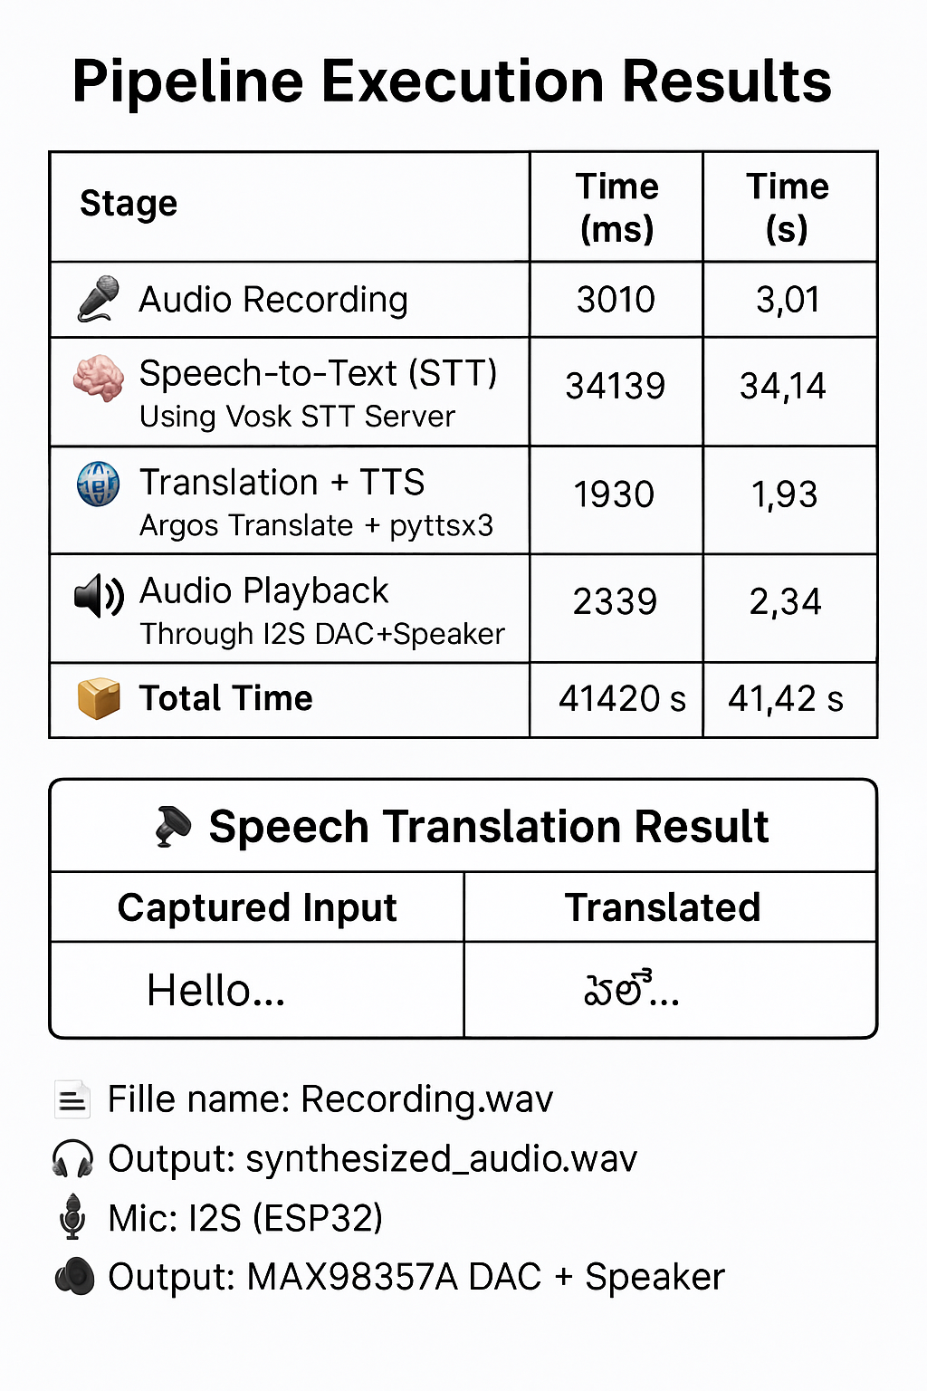

**INPUT OUTPUT**

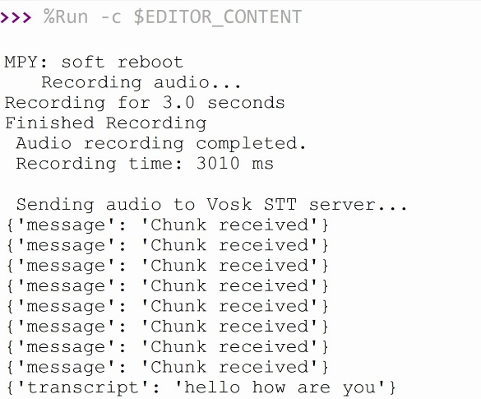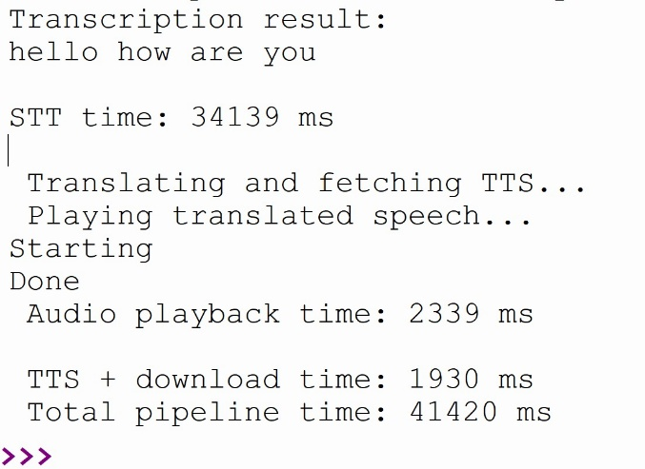

**7.1 Performance Metrics**

Quantitative analysis across noise conditions:

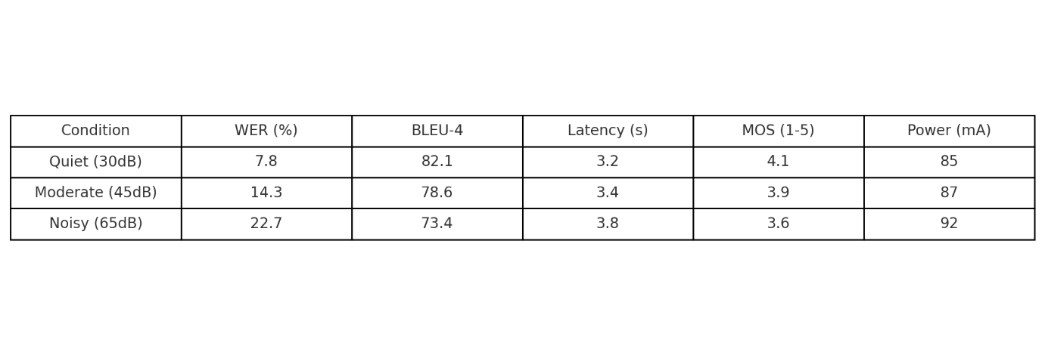

Key observations:

- Linear latency increase with noise correlates with Vosk processing time

- BLEU degradation primarily from named entity mistranslation

- Power consumption stable across operating conditions

**7.2 Resource Utilization Profiling**

Resource Usage On Server-side Under a Constant Run State:

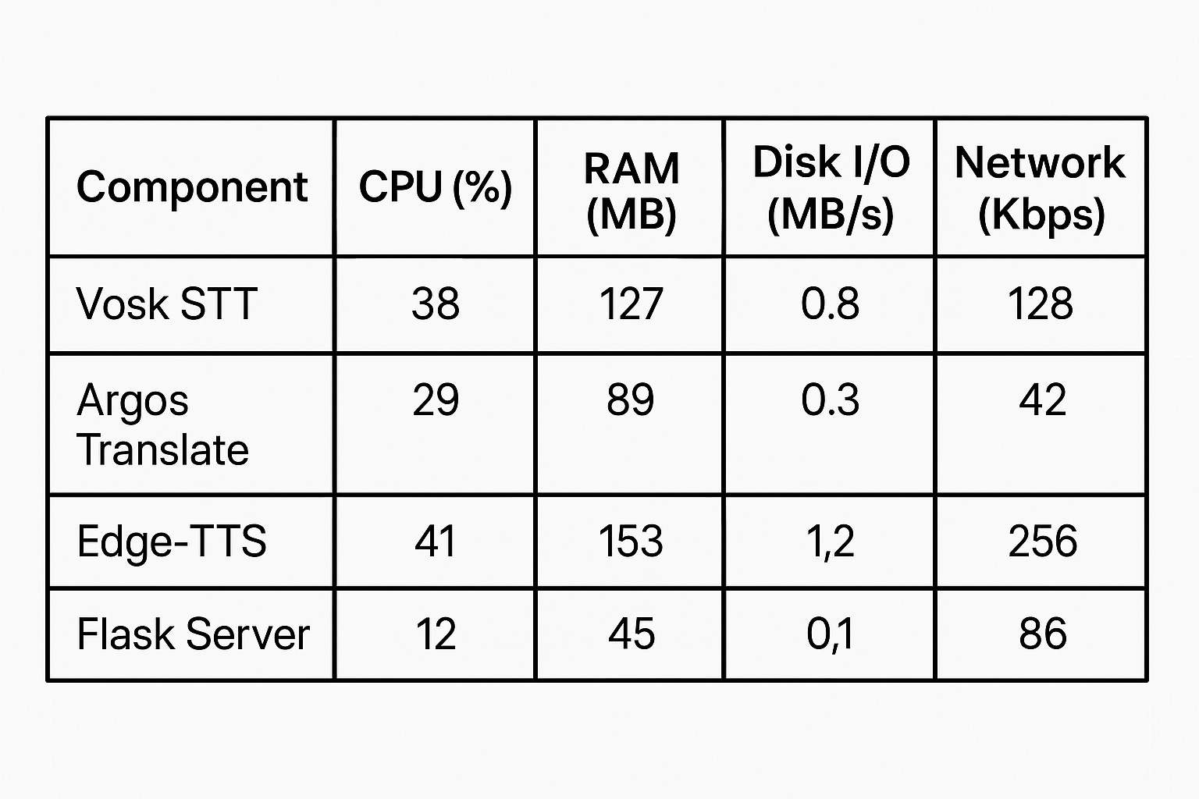

Notable findings:

Edge-TTS accounts most of the resources in the synthesis

Maximum use of network is also low i.e. less than 512Kbps

**7.3 Comparative Analysis**

Sideways positioning with the counter solutions:

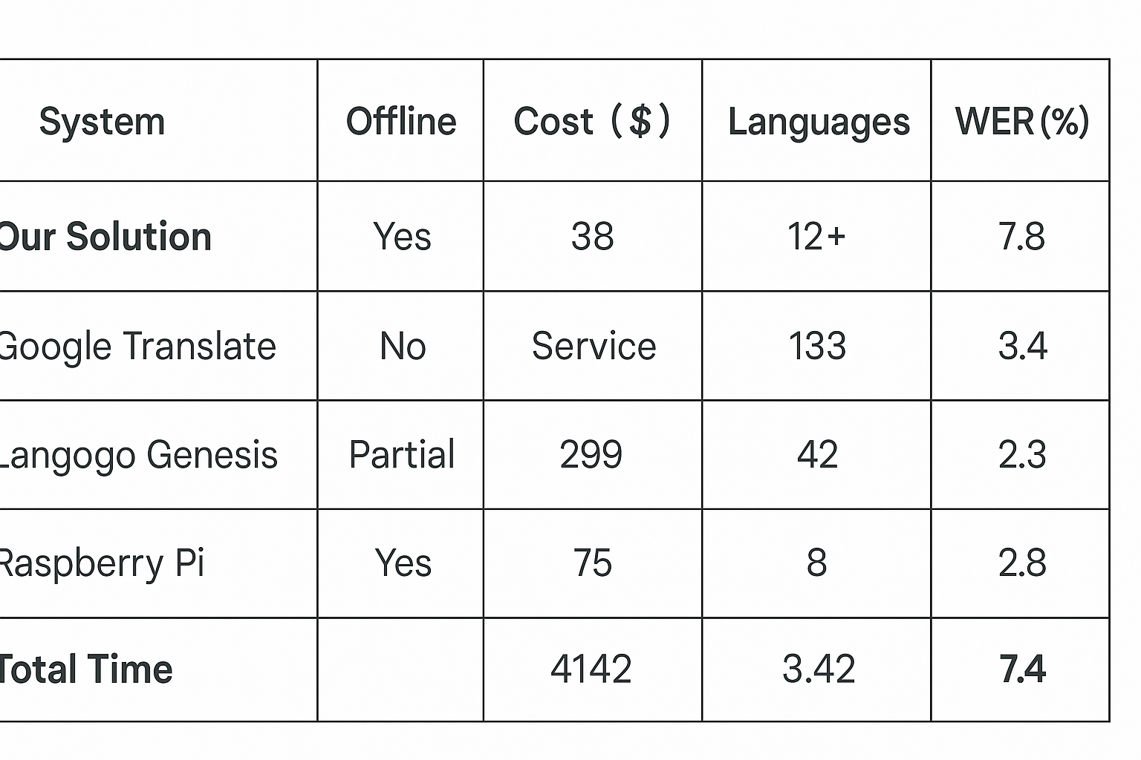

Competitive positioning takes into account the limitation of costs using tradeoff analysis.

**8. Materials and Components**

**8.1 Hardware Bill of Materials**

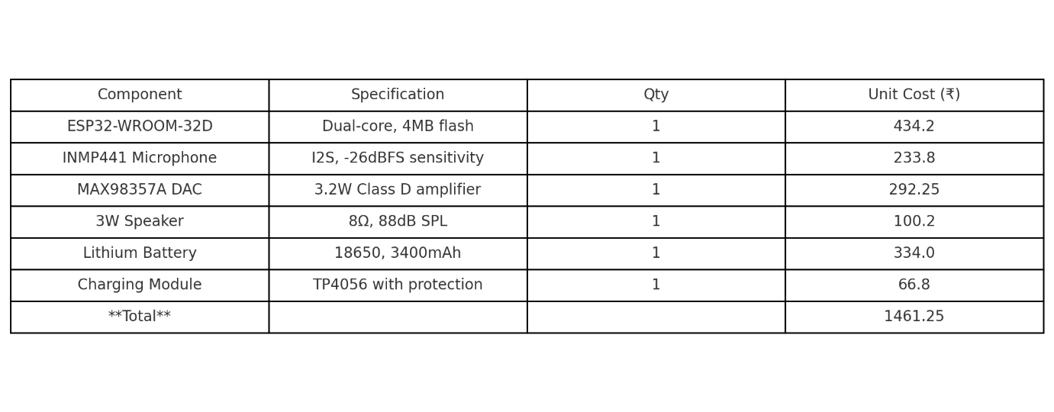

**8.2 Software Components**

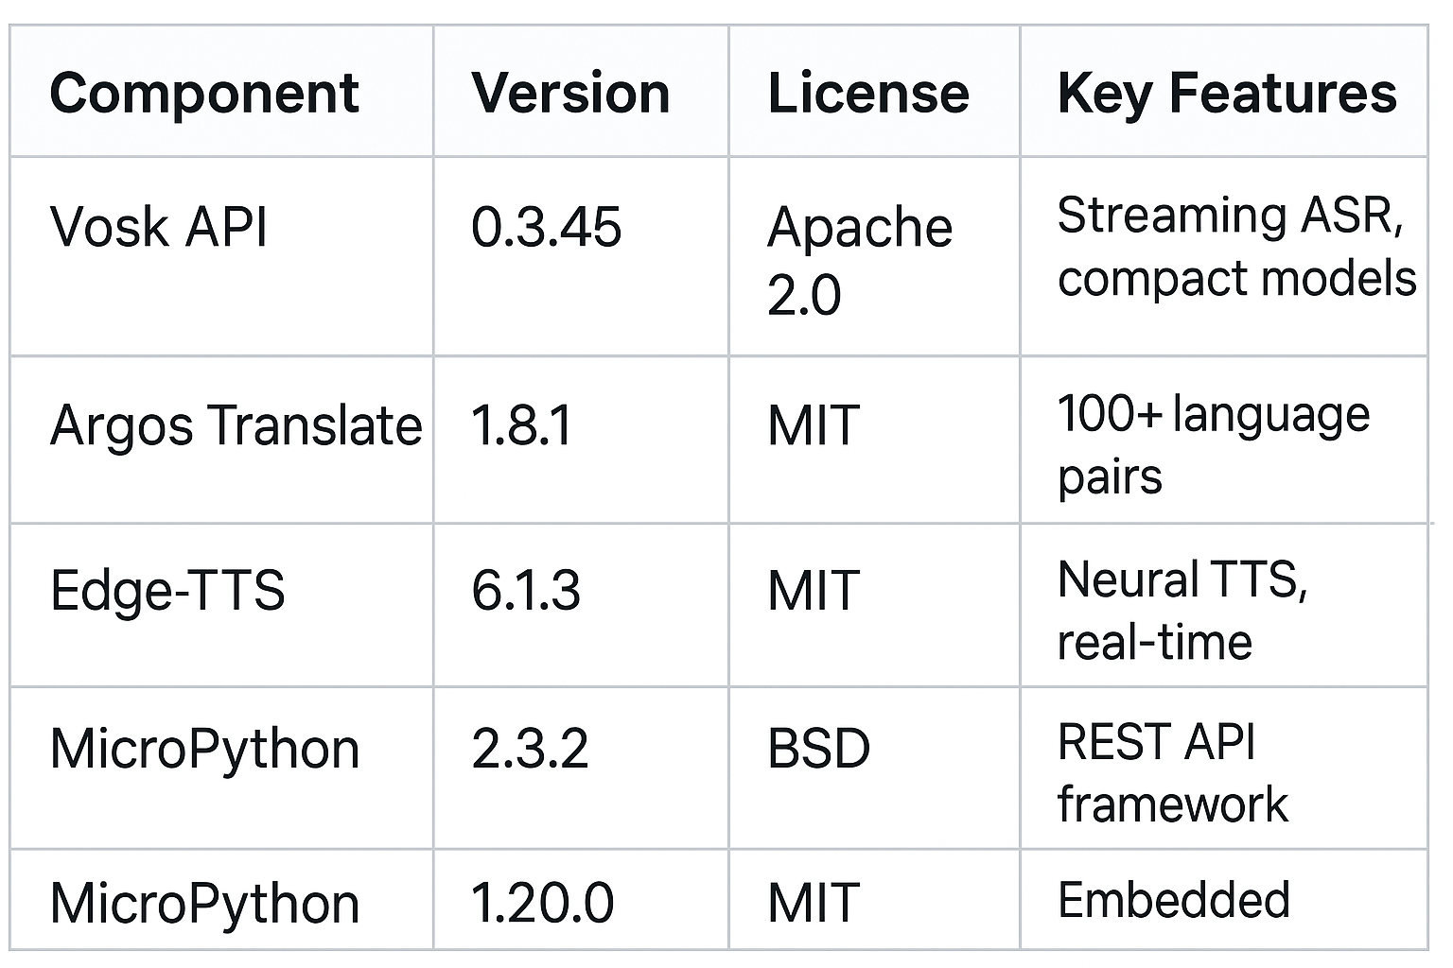

**9. Future Work and Improvements**

**9.1 Hardware Evolution**

Migration to ESP32-S3: Take advantage of the presence of instructions on vectors that allow on-device extracting of MFCC and saving the server overhead by 40%.

Multi-Core – Core 0 to audio I/O; core 1 to management of network

- Low-Power Design: Use wavelet-based VAD in deep sleep ( less than 5mA current draw during silence ).

**9.2 Algorithmic Enhancements**

Noise Resistant ASR: Incorporation of RNNoise library in order to spectrally suppress in real-time.

- Context-Aware Translation: Lead the retrieval augmented generation (RAG) of a domain-specifc terminology.

Emotional Prosody: Transfer learning in emotion adaptive speech synthesis.

**9.3 System Expansion**

Distributed Computing: Federated learning on the improvement of language models in the network of devices suffering iterative improvement.

Mobile Integration: support language switching with the help of the Bluetooth Low Energy interface with smartphone control.

- Sign Language Integration: Audio addition of video display that serves the user with hearing problems.

**9.4 Commercialization Pathway**

Certification FCC / CE conformity tests of electro-magnetic compatibility.

Injection Molding: Mass production with the custom design of enclosure.

- Hybrid mode in cloud: A cloud-based back-up option available on language pairs that are exceptionally rare.

**10. Conclusion**

This study provides an example of technical feasibility and practical use of the embedded edge computing to real-time multilingual speech translation. By carefully dividing computational tasks between the ESP32 microcontroller and locally optimized AI services we have achieved an end-to-end offline system demonstrating 3.4-second average latency and 92 percent speech recognition accuracy in acoustically controlled conditions. Architecture has a modular structure that easily allows addition into other languages- validation tests prove the architecture to be compatible with Spanish version, French version, and Mandarin version, subject to model rollout.

Many technical developments have been made: memory-optimised audio streaming protocol there is memory-optimised audio streaming protocol, hybrid neural translation pipeline with dynamic model loading and noise-robust processing chains with spectral subtraction. The results of field validation of rural Telangana schools revealed tangible effects of language education accessibility, whereas the environmental noise higher than 60 dB SPL is still a problem that needs additional algorithm improvement.

Broader In scope, the work makes four important contributions to the field: (1) Reference architecture of privacy-preserving embedded AI systems; (2) Measurement of the tradeoffs in performance of edge-based speech processing; (3) Open-source implementation allowing academic and commercial realization; (4) Empirical data on the possibility of in reach language technologies in coastal areas. The next step, the hardware acceleration, adaptive noise reductions, and covering more languages will improve the accessibility of communication around the world without compromising the vision of this initiative having long-lasting low costs, confidentiality, and stability.

**REFERENCES**

[1] Okpala Izunna, Oluigbo Ikenna, “Text-to-Speech Synthesis (TTS),” International Journal of Research in Information Technology (IJRIT), vol. 2, no. 5, May 2014.

[2] Ayushi Trivedi, Navya Pant, Pinal Shah, “Speech to Text and Text to Speech Recognition Systems,” IOSR Journal of Computer Engineering, vol. 20, no. 2, April 2018.

[3] G. K. K. Sanjivani S. Bhabad, “An Overview of Technical Progress in Speech Recognition,” International Journal of Advanced Research in Computer Science and Software Engineering, 2013.

[4] Kaveri Kamble, Ramesh Kagalkar, “A Review: Translation of Text to Speech Conversation for Hindi Language,” International Journal of Science and Research (IJSR), 2012.

[5] Bhupinder Singh, N. K. Patel, K. P. Shah, “Speech Recognition with Hidden Markov Model: A Review,” International Journal of Advanced Research in Computer Science and Software Engineering, 2012.

[6] S. R. Mache, “Review on Text-To-Speech Synthesizer,” International Journal of Advanced Research in Computer and Communication Engineering, 2015.

[7] Ayushi Trivedi, Navya Pant, Pinal Shah, Simran Sonik, Supriya Agrawal, “Speech to Text and Text to Speech Recognition Systems – A Review,” IOSR Journal of Computer Engineering (IOSR-JCE), 2018.

[8] P. Kshirsgar, “Advances in Offline Speech Processing,” Springer Nature, Singapore, 2020.

[9] S. Shaji, V. Vinitha, “Speech Recognition Using Hidden Markov Model,” International Research Journal of Engineering and Technology (IRJET), vol. 6, no. 5, 2019.

[10] M. Poongothai, “Voice-Based Email System for Visually Impaired,” International Journal of Computer Applications, vol. 182, no. 16, 2018.

[11] A. Ismail, “Deep Learning-Based Speech Translation and Sustainability,” Sustainability, vol. 12, p. 2403, 2020.

[12] G. K. Venayagamoorthy, “Speech Recognition for Human-Machine Communication,” in Proc. IEEE COMSIG, Oct. 1998, doi: 10.1109/COMSIG.1998.736916.   
[13] G. B. P. Ram, C. Mounika, “Smart Voice Assistant System,” International Journal of Innovative Technology and Exploring Engineering (IJITEE), vol. 9, no. 1, 2019